Story

No se esta mostrando los texto de terms and conditions

Evidence

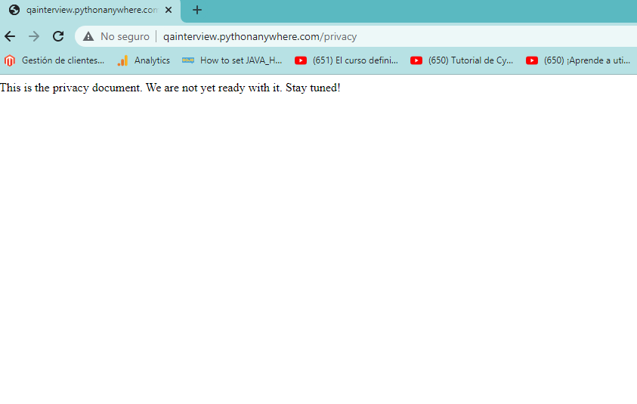

How to reproduce  
1.ir a <http://qainterview.pythonanywhere.com/>,

2.Clic en terms and conditions

3. Muestra mensaje de error

Acceptance criteria

* terms and conditions deben de mostrarse

Context

\*Mark with an "x".

Environment:  
[x] prod  
[] staging  
[ ] development  
[ ] local

Browser:  
[ ] chrome  
[ ] firefox  
[ ] opera  
[ ] safari  
[ ] edge  
[ ] other, write name:

OS:  
[ ] linux  
[ ] windows  
[ ] mac  
[ ] iOS  
[ ] android  
[ ] other, write name: